PROJECT LOGBOOK

MKU
Mobile Application Development

NAME DENNIS MURUKA
REGISTRATION NUMBER BIT/2025/67727
COURSE UNIT MOBILE APPLICATION DEEVELOPMENT (BIT 4107)
INSTITUTION MOUNT KENYA UNIVERSITY THIKA MAIN CAMPUS
DEPARTMENT COMPUTING AND INFORMATICS
LECTURER MR NYORO MICHAEL

INDEX
- Week 1 — Flutter Doctor: Environment Verification
- Week 1 — Android SDK Licenses Accepted
- Week 1 — Connected Devices (flutter devices)
- Week 1 — Default Flutter Application Running on Mi 8
- Week 1 Assignment — Customized App Title, Theme & Welcome Text
- Week 2 — Interactive ElevatedButton ("Click Me") Implemented
- Week 2 — TextField User Input Widget
- Week 2 — Dynamic State Management (TextEditingController + setState)
- Week 2 Assignment — Mini Student Management App: Login Page
- Week 2 — Terminal Output: Captured Username & Password
- Week 2 — Student Management App: Home Page
- Week 2 — Student Management App: Register Student Navigation
- Week 2 — Student Registration Form (Data Entry Tested)
- Week 3 Assignment — Figma High-Fidelity Prototype (Navigation Flow)

TASK 01

Flutter Doctor: Environment Verification

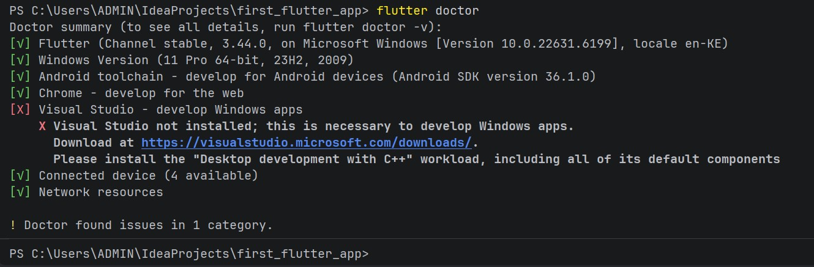

TASK 02
Android SDK Licenses Accepted

TASK 03
Connected Devices (flutter devices

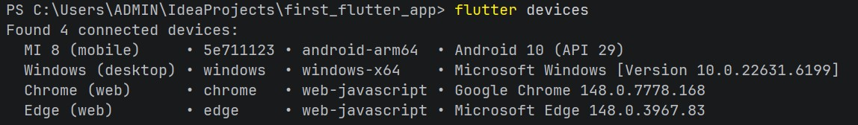

TASK 04
Default Flutter Application Running on Mi 8

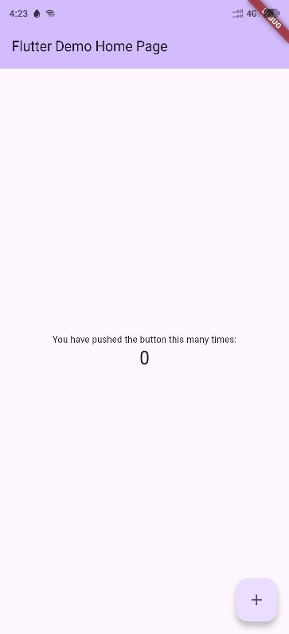

TASK 05
Customized App Title, Theme & Welcome Text

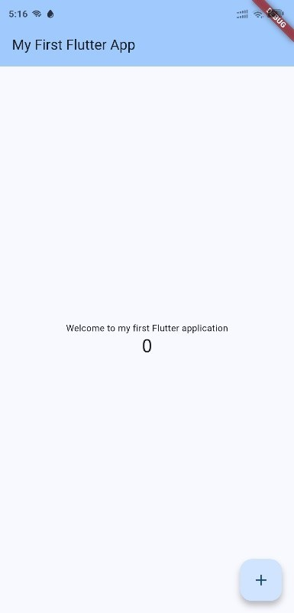

TASK 06
Interactive ElevatedButton ("Click Me") Implemented

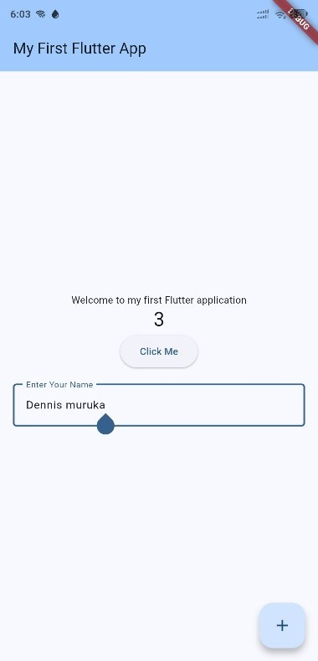

TASK 07
TextField User Input Widget

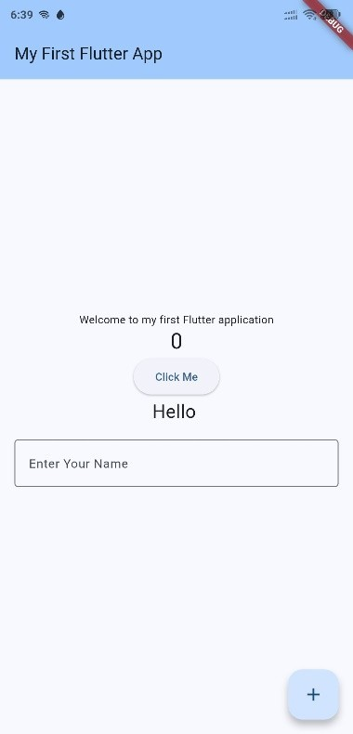

TASK 08
Dynamic State Management (TextEditingController + setState)

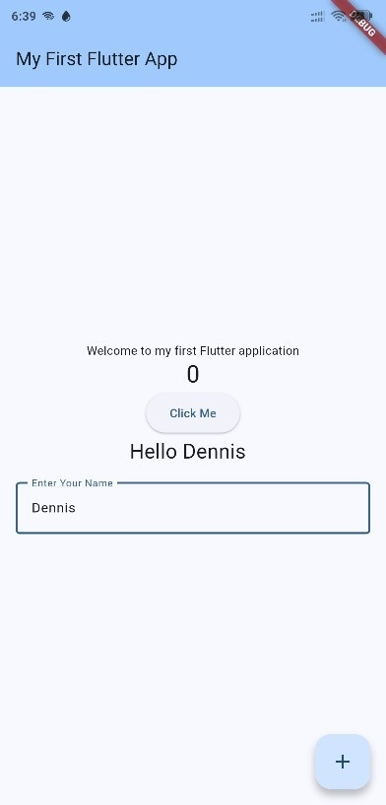

TASK 09
Mini Student Management App: Login Page

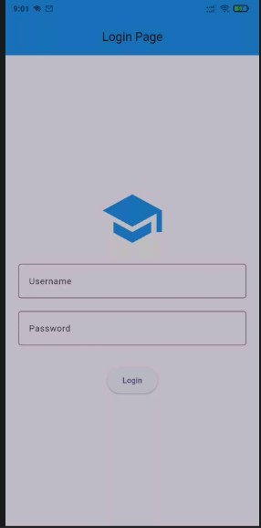

TASK 10
Terminal Output: Captured Username & Password

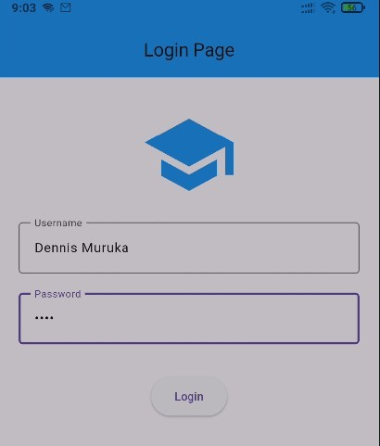

TASK 11
Student Management App: Home Page

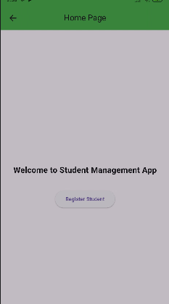

TASK 12
Student Management App: Register Student Navigation

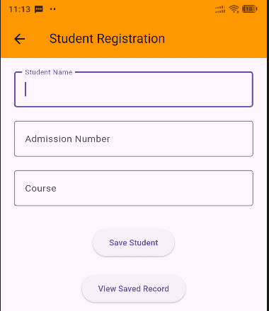

TASK 13
Student Registration Form (Data Entry Tested)

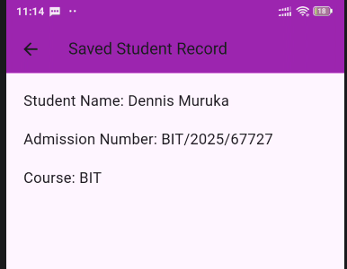
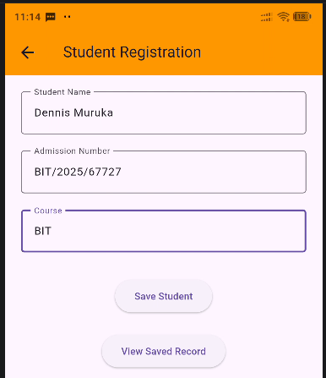

TASK 14
Figma High-Fidelity Prototype for the mini student management system (Navigation Flow)

Link to my Figma project
https://www.figma.com/design/XT59c1EpC7qF9apwKLS2re/Splash-Screen?node-id=0-1&t=mCkL3m6Uv2Zu73rb-1
